|  |
| --- |
| University of Gloucestershire |
| CT5006 Mobile Application Development |
| [Type the document subtitle] |

|  |
| --- |
| Rouge, Cleveland  2/10/2015 |

Final Report – Mobile Application Development ct5006

Contents

Introduction 2

Planning– Wireframes/Colour scheme/Site map/logo 2

Use OF HTML and CSS/CSS3 Media Queries /theme 4

User interface components and framework ( Sencha/JQTouch) and APP Icon 4

CSS and CSS3 elements 4

Use of HTML 5 elements 5

Native Device Functionality’s 5

Data Storage (SQlite, IndexedDB, PHPH/MySQL) 5

Testing – Browsers/devices/Orientation 5

References 5

# Introduction

# Planning– Wireframes/Colour scheme/Site map/logo/maps debate



logo - Figure 1

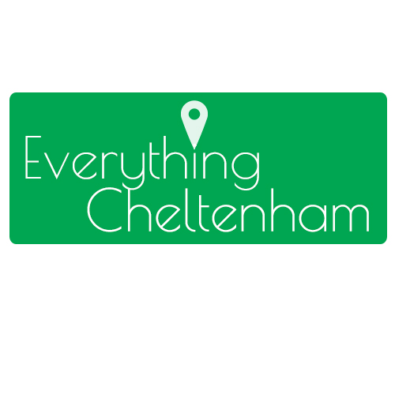

Logo - Figure 4

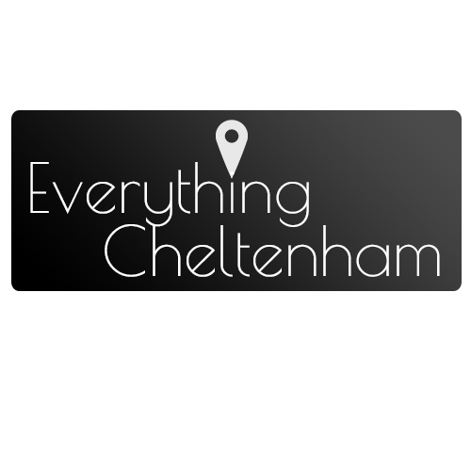

logo - Figure 3

logo - Figure 2

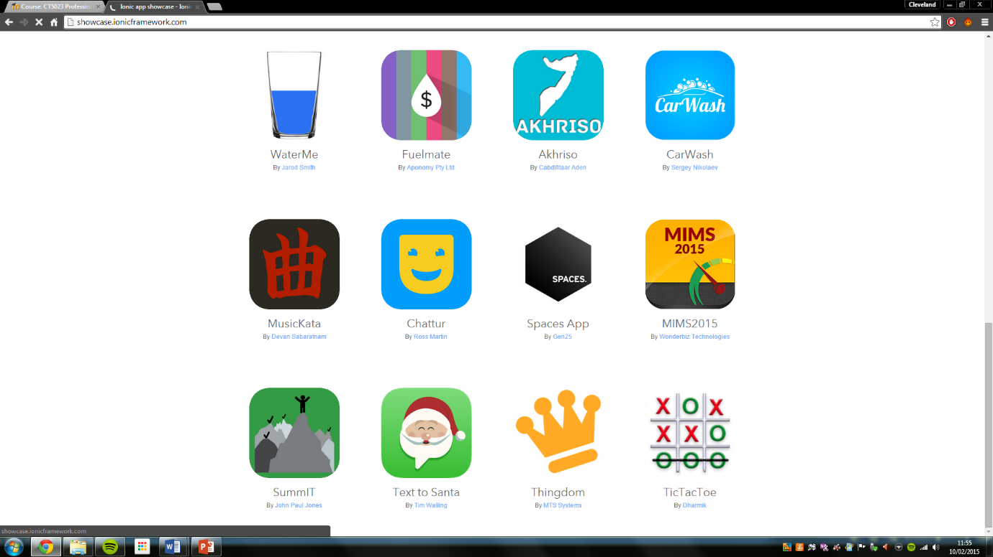

Logo – figure 1.2

Before beginning to create our mobile application we decided it would be a good idea to take time to ensure planning was to a high standard to allow the build of the application more understandable.

Firstly, we decided we should create an identity behind our project in the form of colour schemes, a logo and website name. Above you can see 4 logo ideas which we had played around with *figure 1* being our initial idea to *figure 4* being our final design.

Our initial idea came from a logo found on <http://showcase.ionicframework.com/> (Figure 1.2). We used the shape of the logo and colour scheme as w4e believed this was a smart logo which for its simplicity would come of great benefit for our use. After this we began to think about the implication of the shape of the logo into our hybrid App. We believed that the hexagon not only would be difficult to use but we believe there was much wasted space for our design and therefore decided cropping into a rectangular shape would be more beneficial to our needs. Figure 3 is a representation of this transformation.

Explain figure 2 and colours woulkdnt work to what we need and would cause complications and figure 4 was final design and why we believed it worke and alkso talk about font poiret one (google fonts)



Application icon - Figure 1



Application icon - Figure

Fonts- Poiret one (logo)

# Use OF HTML and CSS/CSS3 Media Queries /theme

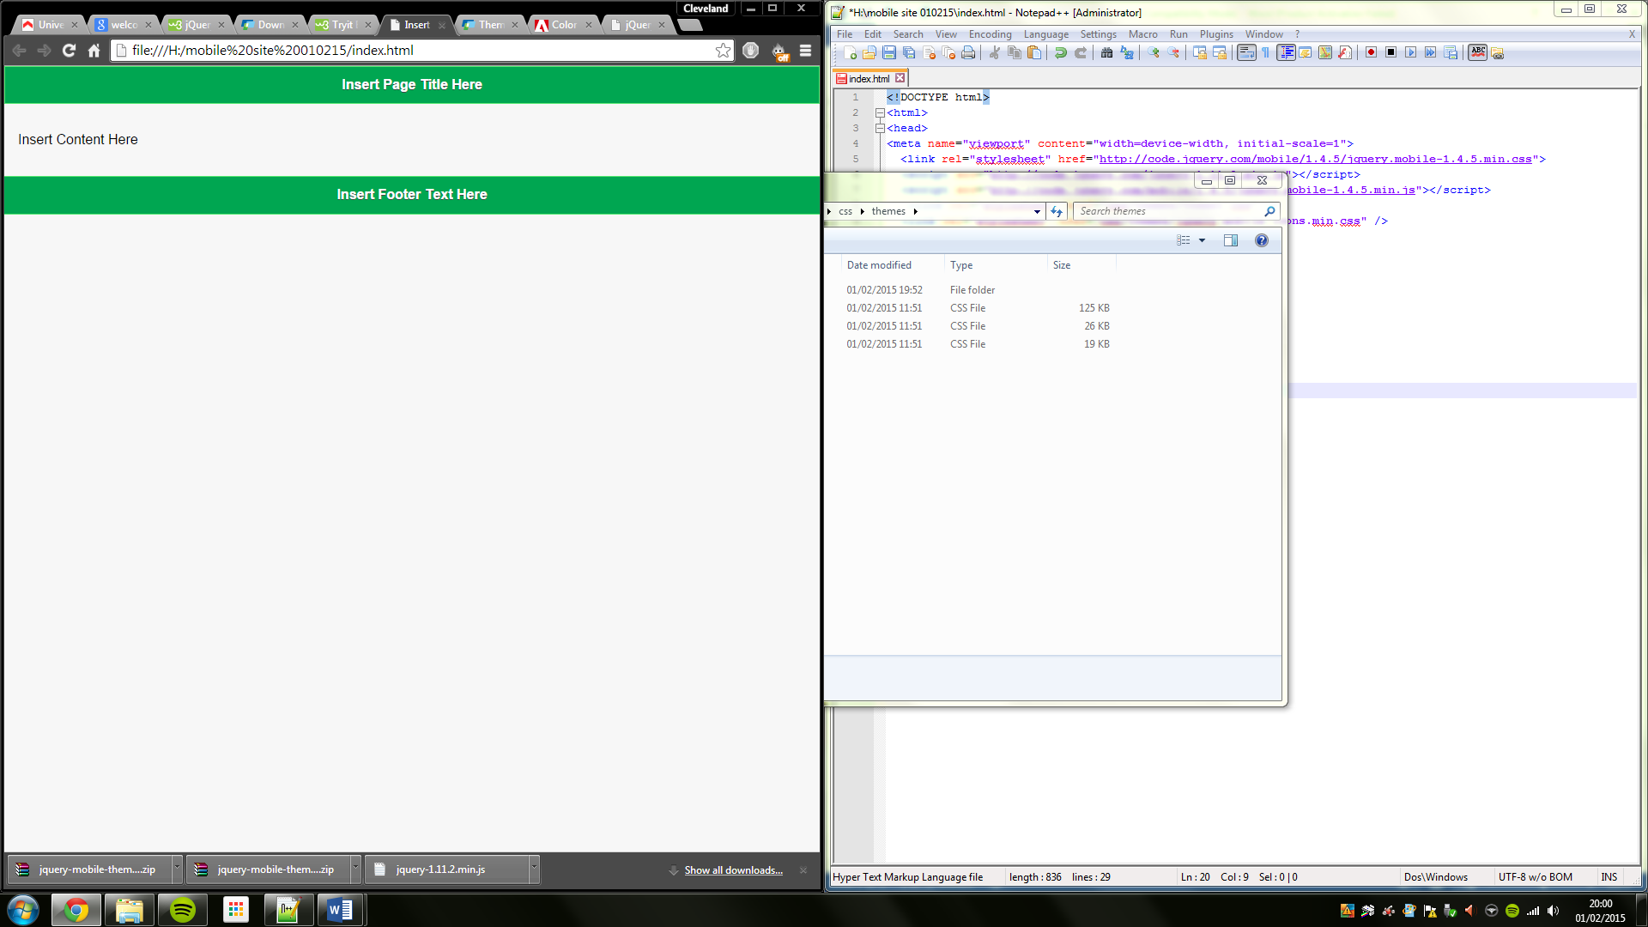

# User interface components and framework ( Sencha/JQTouch) and APP Icon

Sench/  
 jqtouch   
/chocolate chip UI   
/Ionic framework http://showcase.ionicframework.com/  
/APPmOBI/   
Intel XDK  
 Kendo  
 Angular Material https://material.angularjs.org/#/

# CSS and CSS3 elements

# Use of HTML 5 elements

# Native Device Functionality’s

# Data Storage (SQlite, IndexedDB, PHPH/MySQL)

# Testing – Browsers/devices/Orientation

# References

CodePen, (2015). *Medium Scroll Effect*. [online] Available at: http://codepen.io/andreasstorm/pen/pyjEh [Accessed 24 Feb. 2015].